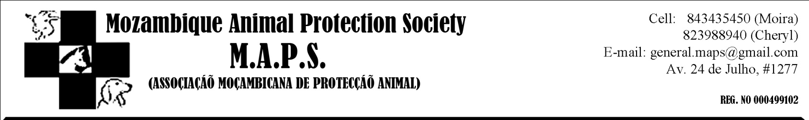
Hi M.A.P.S. friends!
Another month has passed and we are slowly moving towards reaching our goals!

M.A.P.S. has now officially gotten the property we’ve been so madly raising funds for, though it is not yet ready for the dogs to move in. Before we can move the dogs, we need to build a boundary wall. At the moment our dogs are housed with Cheryl (one of M.A.P.S. founders) and are being very well taken care of – THANK YOU Cheryl!

There is a lot of work to be done on the new property, including building kennels, maintenance on the building and many, many more things. We will be sending out a complete list of what needs to be done shortly, as well as photographs of the new property. Please be patient with us while we get this all together for you.

A huge THANK YOU to Michaela Sorrenson for the gift certificate (Creativa) that she so kindly donated to M.A.P.S.
We really appreciate your kindness Michaela!

Please remember M.A.P.S. when doing your grocery shopping this month. We are always in need of dog food and would appreciate anything you could donate. Any food or money can be dropped off at our office in 24 de Julho. Please e-mail donations.maps@gmail.com if you have any questions.

We want to issue a warning to people living in the Truinfo area... we have had a lot of reports recently about dogs being stolen or just vanishing from properties.
Please be extra careful with your pets in the next while!

Dogs stil up for adoption
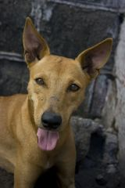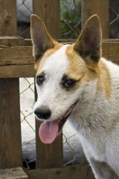
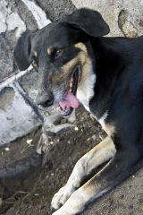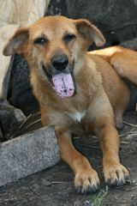

MISSING

Please keep your eyes open for this little guy. He went missing on the 29th June in the Truinfo area. His name is Pedro and he is about 5 months old.
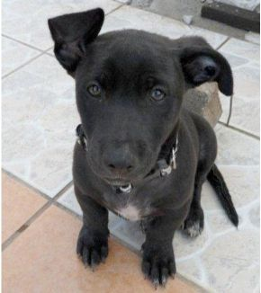

Please contact Dominique Ross - 823198140 / 823008090 if you have any information!

