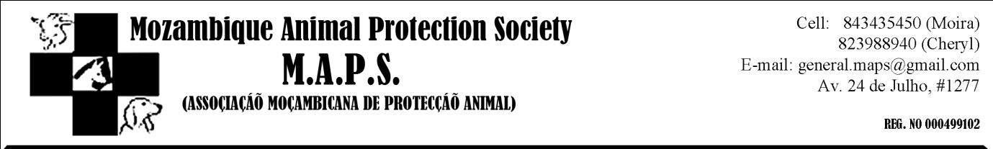

Dear MAPS friends.
With so much negativity in the world today (especially in the area we work in!) good news is always welcome, and so that is why we wanted to share these stories with you...

This month alone, we have been able to reunite 4 lost dogs and their owners. Obviously this is the best result we could hope for when picking up a stray... that some loving family is out there looking for them.

The last dog was especially touching and just goes to show that sometimes we need to listen to that little voice inside...

Sometimes it’s just a feeling we get, a pull towards something that we can’t explain. A need to do something, to stop and make a difference. That is what Pepe felt when she saw a stray dog running across Av Julius Nyerere on Monday afternoon. She had seen many strays around this area before, but this one was different. At first she just drove past, but that feeling persisted. She turned her car around and went back. To her surprise the dog was friendly and jumped into her car very little persuasion, sitting neatly on the seat. The dog was thin, hungry and very very stinky. After taking her to the vet to get dewormed and have flea medication, Pepe took the dog home to have a good bath and some food, hoping that there wouldn’t be trouble with her own two dogs. Late that night she let me know about the dog she had found and I promised to send out a notice to members in the morning.
The next morning while I was on facebook I just happened to come across a link of someone I don’t even know. The link was to a photo he had posted about his missing dog. To my amazement, the missing dog looked alot like the one Pepe had picked up just the night before! I sent her the advert and she contacted the owner straight away. Was this his dog? The area and basic colouring matched. At the same time PETS, the vet clinic where she took the dog to also posted a message on their Facebook page about the dog Pepe had found. Immediately a wave of cross contacts started and eventually Pepe and the person who posted the missing dog add were in contact. She arranged for him to come and see if her stray was his loved dog. He arrived at her house and after seeing the dogs reaction, there was no doubt. Joe (as we found out the dogs name was) was reunited with her family and has gone home safe and sound. Thank you so much to Pepe who listened to that little voice in her head, and was kind hearted enough to stop and make a difference. What a happy ending!

We also recently received a mail from a lady who is needing someone to board her two dogs while she is away:
“...is to ask you or your members if you know of anyone who may be willing to take care of our two dogs from 26 Aug. - 10 September. Normally, this is not a challenge, but on 3 March our dog (a German Short Haired Pointer puppy) was given an injection for bloody diarrhoea that severed his sciatic nerve. Despite the integrity and true interest of the vet to address the ensuing problems, a series of non-stop problems have followed - one ''solution'' has generated another problem. Without going into the details in this message, we need someone who truly loves dogs and who is willing to do a dressing change every other day on a funky back paw and to take our dog to the vet (we just have started going to VAL) from time to time while we are away. We also have a 95% Jack Russell who loves the Pointer (named Biko) who needs care as well. I am willing to pay someone who is willing to board them at their house and do this - as long as I know they also are dog lovers and know how to take care of them. They are both sweet animals and like people. I am happy to supply more details, but this is the story in brief.”
If anyone feels they could take these 2 dogs for the two weeks while she is away, please contact me on general.maps@gmail.com

Lastly, one of our members has puppies for sale:
Beautiful female bullterrier for sale, 2 months old, and a black and brown Maltese and teacup Yorkshire mix for sale. For more info contact 825967734.

Please remember that while we will put out the word if people have puppies for sale, MAPS does not endorse breeding dogs for sale, but recommends having your dogs spayed. Every year between 6 and 8 million unwanted animals are killed in shelters worldwide. Instead of letting your dog have puppies, encourage people to go to the shelters where there are always many, many dogs who are desperately in need of loving homes. Be responsible and don’t add to the problem. Be educated and make informed decisions. That’s how we change the world!

