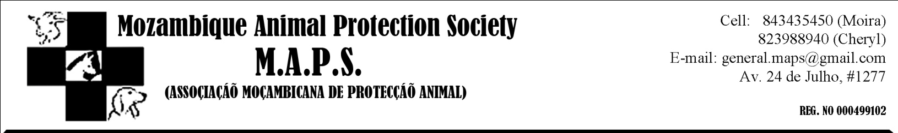

Dear MAPS friends.

July has been a busy month for many of us, what with the Soccer World Cup and school holidays, and has been no less busy for us at MAPS.
We now have 5 dogs at the shelter – which is stil at Cheryl’s guest house as the new property has unfortunately fallen through (please read more about this further on in this newsletter). 2 of our dogs found new, loving homes this month. Preta (the dog who had the puppies earlier this year) is settling down and becoming part of the family and Emma is waiting to go to her new family later in the month. 1 new dog (Christi) was brought in thanks to concerned animal lovers.

We have had numerous e-mails and telephone calls from concerned people over the past few months, with tips about abused, neglected or stray animals. We really do appreciate all these tips, but feel that we need to outline what MAPS is and is not allowed, by law, to do.
Currently there is no legislation in Mozambique protecting animals again abuse, neglect or cruelty. Our aim is to change this legislation but it will take YEARS to do this. Currently MAPS has no authority to confiscate, prosecute or demand that anyone stop abusing or neglecting animals. As frustrating as this is, this is the exact reason that MAPS was formed!
MAPS was formed firstly as an educational organization, and secondly as a shelter. We will never turn an animal away, but our top priority is education and changing legislation. Without these two the long-term problem will never be solved!
We will do everything we possibly can to help any situation where there is abuse, neglect or cruelty, but with no legislation behind us, it can be very difficult. We are currently investigating municipal by-laws to see if anything exists.
If it’s an issue of noise (dogs barking all night etc) we suggest you call the police, as they can enforce this. If it is abuse or neglect, all that can be done under the current law is to appeal to the owner of the animal. MAPS will help where we can but please remember that it takes years to change legislation, and even longer to change a country’s outlook on animals.

"Teaching a child not to step on a caterpillar is as valuable to the child as it is to the caterpillar." -- Bradley Miller

Our website is stil not up and running as we are stil looking for a company willing to host it for us. If you know of anyone who might be able to help with this, please let us know as the website would be a huge help in raising awareness and funds for MAPS!

Thank you so much to Abigail who is fostering Sereia. Please see the article below that was written by the people who found her, and published in the LM electronic newspaper.

“A second chance at life
My mother told me later on that it was only the slight movement of her head as my mom passed her on the beach that gave her away as a living creature. Tightly curled-up underneath long strands of seaweed and swathes of wet beach sand, the little white dog was easily-mistaken for a small pile of sea debris, deposited onto the beach with the previous night’s high-tide. I returned with my mom by car with towels in hand to cushion her skeletal frame on our way to the vet. On the advice of Mozambican Animal Protection Society (MAPS) co-founder Cheryl Coleman, we were taking the little stray to Pets Clinic where Dr. Ana Flavia was waiting to receive her. We believed that the best we could hope for our little find was a humane death. Her body was cold and her limbs stiff; she had been too weak to even move herself away from the lapping waves. We thought that she must be dying. Dr. Flavia met us in the reception of her clinic, and taking the dog from us said that she would do what she could. As she handled her, our hearts ached as the starving little animal, forgotten by society and left to die, found the energy to cock her tail in her best effort at a wag. We left expecting a phone call from Ana telling us that the little dog hadn’t made it, but a few days later, when we phoned to enquire after her, we were surprised to hear that our foundling was doing better! Lots of worms, Ana said, and severe malnutrition, but other than that the little dog had nothing more serious the matter with her. One week passed and we went to visit. We found her at the vet’s entrance, sitting on a blanket in the sun. She held her head up and wagged her tail furiously at our approach. The biggest change was in her eyes, which were wide, bright and gleaming with new-found health. We would like to make a special thank-you to Dr. Ana Flavia, who made herself available on a Sunday, worked miracles with the little dog, and did not charge for boarding and feeding costs. Pets Clinic is located in Maputo at No. 427 Paulo Samuel Kankomba Rd. You can reach Dr. Ana Flavia on 84 360 0036. We would also like to thank MAPS for their dedication to the care of all animals in Mozambique and for their assistance throughout this process.”

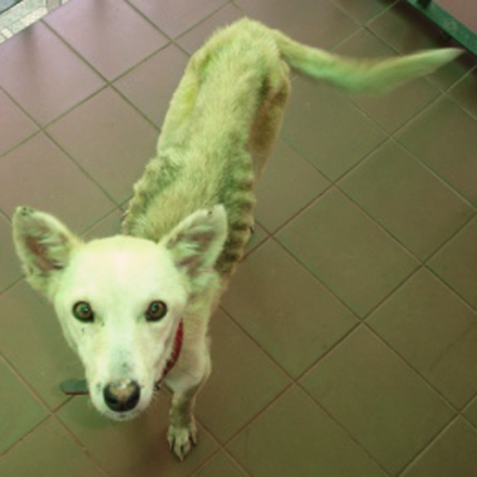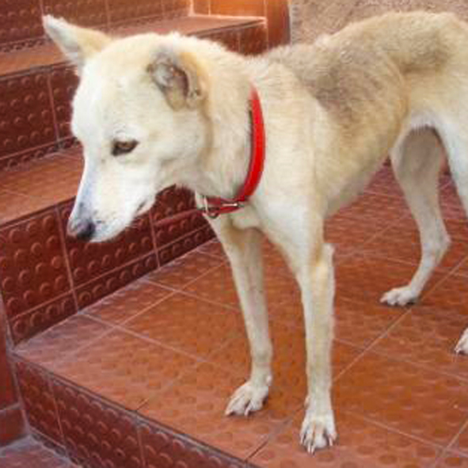
After just 2 weeks!
Before...

With regards to the MAPS property...
As I mentioned at the beginning of this newsletter, the property that MAPS had acquired as an office and shelter has fallen through, but thanks to Johan from JHI, we’ve found an even better property in Matola!
We are yet to sign the contract, but it does look very promising and if all goes well should be signed by the end of the month.
What makes this property even better than the last one, is that there is alot less work to be done. Those that were there at the last meeting in Matola (when we viewed the other property) will remember how much work there was to be done there!
This house is ready to live in! The garden is wonderful with lots of trees and grass. I did go past there today to take some photo’s but the gate was locked and so I could only photograph the front, but it should give you some idea of what it looks like!

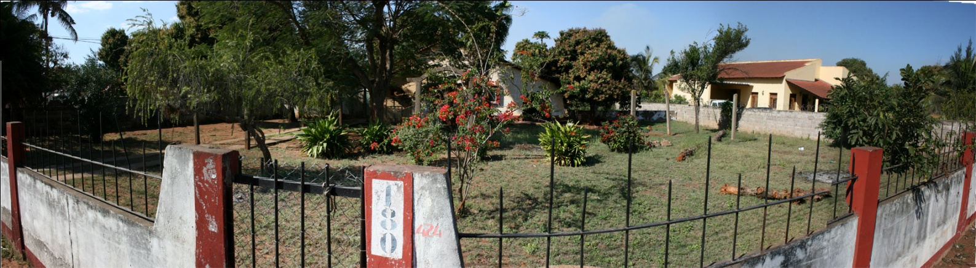

I will keep you updated to the progress!
In the meantime, we are going to be needing furniture. So if you are throwing out any furniture like chairs, tables, desks, filing cabinets, bedroom furniture or kitchen stuff please let us know! Even if it needs fixing up! Please keep us in mind in the future if you are getting rid of anything you think might be useful to us!

One of our members if looking for a small breed puppy. MAPS has no puppies at the moment, so if you have some that need homes please let us know and we will pass the message on!

Our next meeting will be held on the 28th August in Matola. We will meet at Mundo’s in the Shoprite complex. I will send out further details closer to the time!
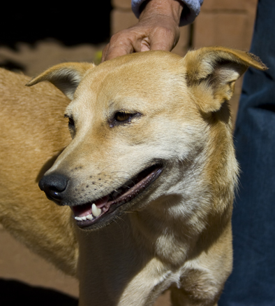

Christi is our newest dog.
She is a very playful, energetic, loving dog that gets on well with the rest of the dogs and loves nothing more than hugs and kiss!

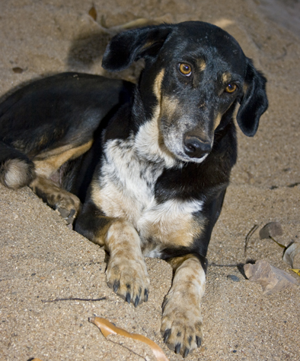

Rafa has been with us for a while and can be a little shy, but is quiet and doesn’t cause any trouble. She just needs a nice, quiet home with someone to love her.
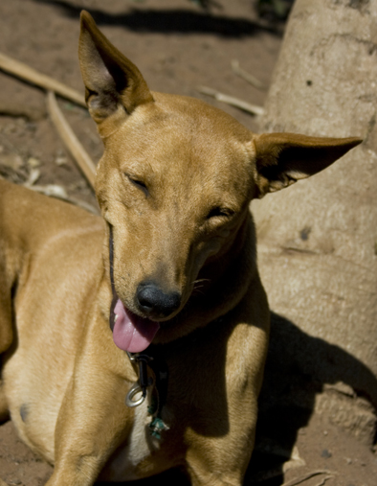

Lessie is our lady. She has such a gentle soul and loves to just sit next to you quietly and watch the world. She is very loveable and walks beautifully on a lead!

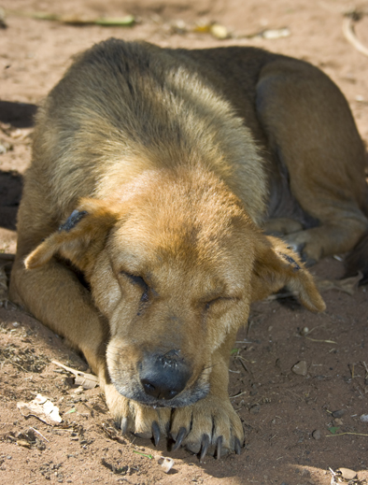

Sally is our old lady. She was very shy in the beginning, but has come out of her shell amazingly.

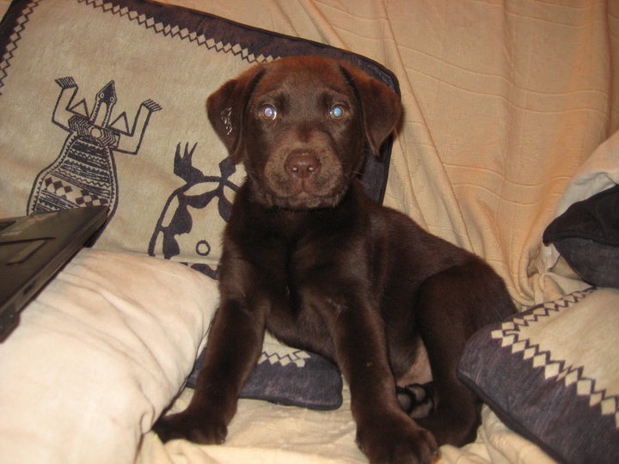

PLEASE HELP: LOST DOG, 3 MONTHS ONLY, LABRADOR, BROWN, LOST IN RUA GENERAL PEREIRA D'EÇA, POLANA AREA, YESTERDAY (9TH OF AUGUST) AROUND 7 PM. IF YOU SEE HIM PLEASE CONTACT 823212870. THANK YOU

